**Step1: identify entities:**

**Step2: identify key attribute/s for each entity.**

**Step 3: draw the relationships.**

According to the missing value check, a track will always be assigned to an album

And this part of code shows that a track belongs to one album only, an album belongs to one artist only.

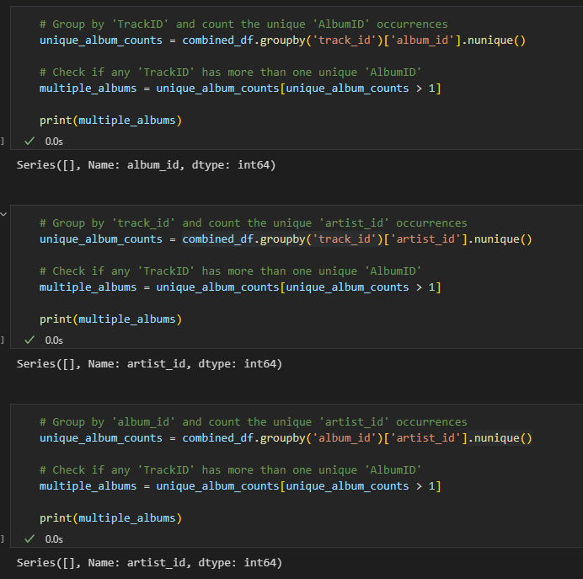

So the relationships:

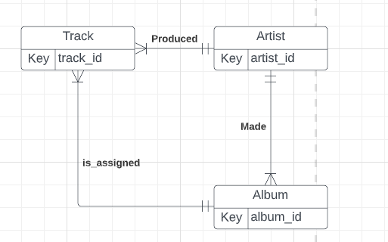

**Step 4: add non-key attributes:**

Record_date -> multivalued attribute

Popularity -> multivalued attribute

Artist popularity -> multivalued attribute

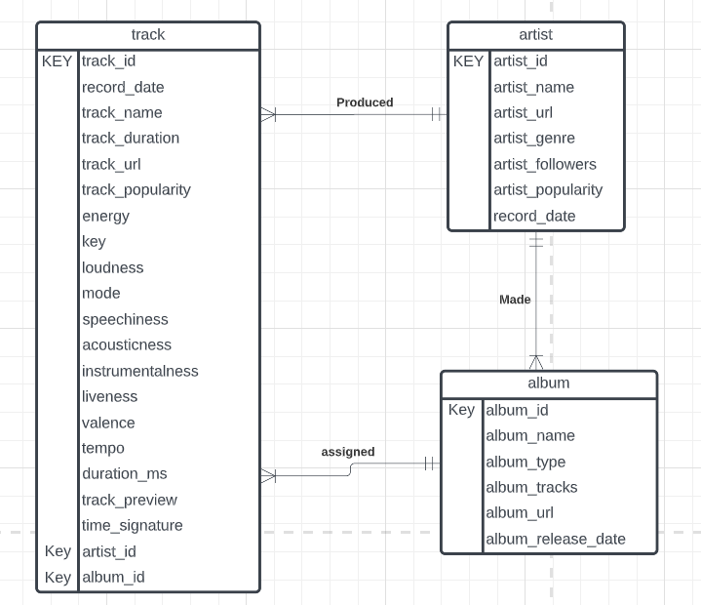

**Step 5: remove multivalued attribute and create a new entity**

**Step 6: Drawing Logical Model, Identify Primary Key and Foreign Key**

**Step7: Set constraint and add new entity based on case study**

**case**: spotify has top songs playlist for country, all of these tracks are found from those playlists

**Action:** add playlist entity

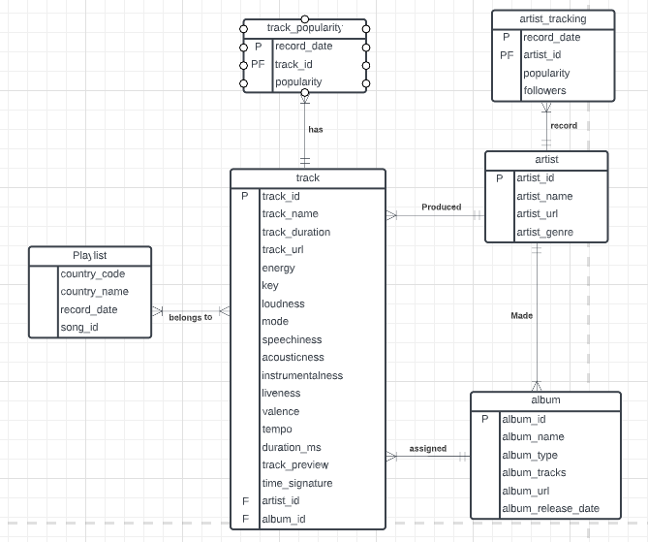

A playlist contains one or more tracks, and a track can belong to one or more playlist, now it is a composite entity. Therefore, I will create a bridge entity: Playlist_track_id

